Getting-to-Know-You Venn Diagram
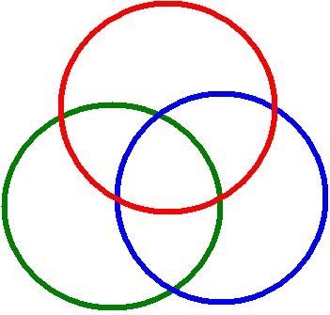
In groups of three students. Students talk in their groups about themselves and the things they like to do or their favorite book, movie, food, etc. After a brief discussion, On a whiteboard, Draw 3 HUGE intersecting circles.

Put one person’s full name outside one of the circles.

decide on at least three ways in which they are all alike; Person RED write those things in the area of the diagram that intersects all three circles.

· find ways in which they are like one other student in the group and Person BLUE record those ways in the appropriate areas of the diagram.

· determine a few facts that make each of them unique and person GREEN write those facts in the appropriate sections of the diagram.

When time is up, Mr. D or k will choose one person to present for the group. That presentation will be assessed using the whiteboard presentation rubric. Note that since this does not involve “scientific concepts” or vocabulary, that aspect of the rubric can be ignored. Instead, you could substitute, “social norms” perhaps.

Whiteboard Presentations Rubric Student/Group

Criteria | 4 | 3 | 2 | 0
Information-written | Information on the whiteboard is accurate and thoroughly addresses the concepts or prompt. | Information on the whiteboard is either partially inaccurate or lacks thoroughness. | Information on the whiteboard is not accurate but shows the task was attempted. | Information on the whiteboard is both inaccurate and lacking thoroughness.
Information-verbal | Student is able to explain the concept outlined on the whiteboard correctly using appropriate science vocabulary, without reading word for word from board, and responds appropriately when questioned. | Student is able to explain the concept outlined on the whiteboard correctly but struggles with appropriate science vocabulary or must read what has been written on the whiteboard or does not respond appropriately when questioned. | Student struggles to explain the concept, by only reading directly from board and failing to use appropriate science vocab correctly, or failing to respond appropriately when questioned. | Student is unable to explain the concept or does not respond appropriately when questioned.
Communication | Student speaks loudly, clearly, fluently, facing the class. Claims are logically supported by evidence and known scientific theories | Student speaks clearly but faces the whiteboard while speaking or is not loud enough or provides only partial logical support for claims. | Student mostly mumbles and mostly faces board, OR provides little to no logical support for claims. | Student does not speak or has no logical support for claims.
Visual | large and clear enough to be read from the back of the class. well organized and free of extra artwork Models are labeled. | The information on the whiteboard is difficult to read from the back of the class OR is disorganized OR contains extra artwork OR lacks an adequately labeled model. | The information on the whiteboard is difficult to read and/or unorganized, contains extra artwork, fails to include appropriate, labeled model. | The information on the whiteboard is illegible, unorganized AND lacks appropriate labeled model.

