Name _____________________________________________________________________________

Dinosaur Scene - Observation and Inference Worksheet

A time machine has been invented that travels into the past and takes pictures, sending them to the present. You are asked to look at one of the pictures and interpret what you see.

____ 1. The volcano is erupting.  ____ 2. The camptosaurus is going to eat the stegosaurus.  ____ 3. The stegosaurus will run into the water to escape.  ____ 4. The camptosaurus is leaving tracks in the ground.  ____ 5. The ground where the camptosaurus is walking is wet.  ____ 6. There are plants growing in the water.  ____ 7. The camptosaurus is going into the water to eat the plants.  ____ 8. There is a tree growing next to the river.  ____ 9. The tree looks like a palm tree.  ____ 10. The climate is warm.  ____ 11. The stegosaurus is eating the plant.  ____ 12. The stegosaurus is an herbivore.  ____ 13. There are bones from a dead animal by the shore.  ____ 14. The camptosaurus killed the animal.  ____ 15. Some more bones are in the water.  ____ 16. The camptosaurus can’t swim and will drown.  ____ 17. Lava is corning down the sides of the volcano.  ____ 18. The camptosaurus has sharp teeth for eating meat. | A. Observation  B. Inference

Suppose you are a paleontologist and you have just discovered a layer of rock with many fossils in it, both petrified bones and tracks.

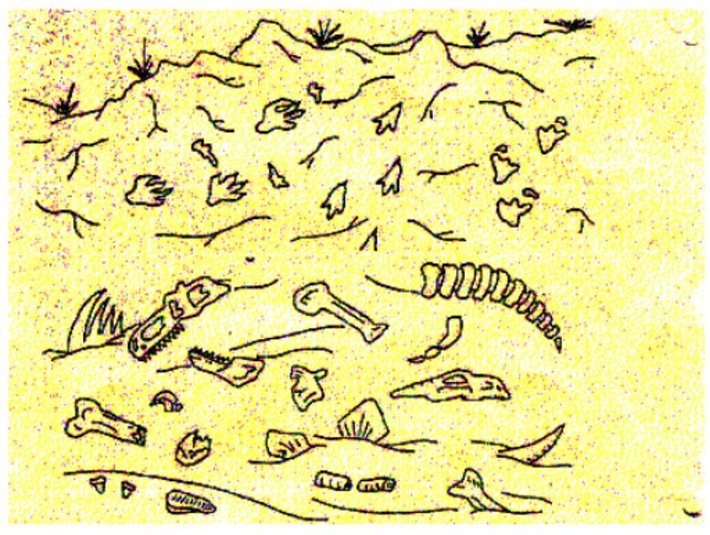

Decide whether the following statements are observations or inferences.

19. _____ There are tracks from three different animals in the rock.  20. _____ One animal was chasing another animal.  21 _____. Two different animals died in this spot.  22. _____ When the animals walked here the ground was wet.  23. _____ One of the animals that died here had bony plates.  24. _____ One of the animals that died here had sharp teeth.  25. _____ The animal that had sharp teeth ate meat. | A. Observation  B. Inference



