**Nature of Science Review Guide**

***Review Questions: These questions are meant to be a way for you to go back and review the main concepts that will be on the test. They are NOT a comprehensive study tool, nor should they be all that you do to study for the test.***

1. What is Science?
   1. Name the 2 types of science and give an example of each:
2. What does CONPTT stand for? (fill in the chart below)

|  |  |
| --- | --- |
| Characteristic | Definition |
|  |  |
|  |  |
|  |  |
|  |  |
|  |  |
|  |  |

* 1. How does that help us determine if something is Science OR Not?

1. Read about the area of study below.

**Dowsing** (sometimes called **doodlebugging**, **divining** or **water witching**) is the action of a person--the *dowser*--using a rod, stick or pendulum--called a *dowsing rod*, *dowsing stick*, *doodlebug* or *divining rod*--to locate such things as underground water, hidden metal, buried treasure, oil, lost persons or golf balls, etc. Dowsing is not based upon any known scientific or empirical laws or forces of nature.

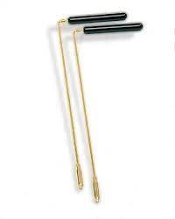Map dowsers use a dowsing device over maps to locate oil, minerals, persons, water, etc. However, the most people think of a dowser in the field who walks around an area using a forked stick to locate underground water. When above water, the rod points downward. Various theories have been given as to what causes the rods to move: electromagnetic or other subtle geological forces, suggestion from others or from geophysical observations and other paranormal explanations, etc. Most skeptics accept the explanation that the rod moves due to involuntary motor behavior.

* 1. Is this science?
  2. Why or why not? (use CONPTT)
  3. How many of the characteristics of science does an area of study have to have to be considered a science?

1. Make an inference for each of the following observations.
2. 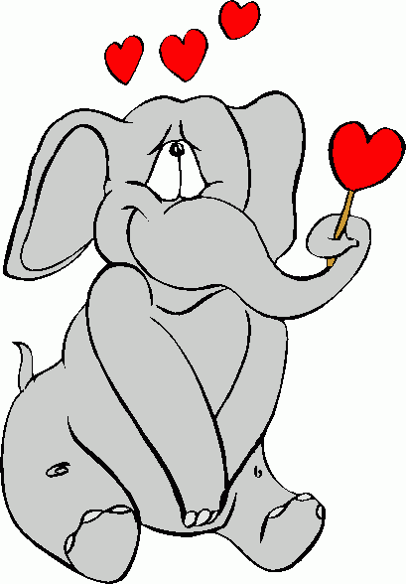Write **O** if it is an observation and **I** if it is an Inference:
   1. There is 1 elephant.
   2. The elephant is in love.
   3. There are 4 hearts surrounding the elephant.
   4. The elephant likes lollipops.
   5. The elephant’s trunk is wrapped around a stick.
3. Which of the observations above are **quantitative**? __________________
4. Which of the observations above are **qualitative**? _____________
5. 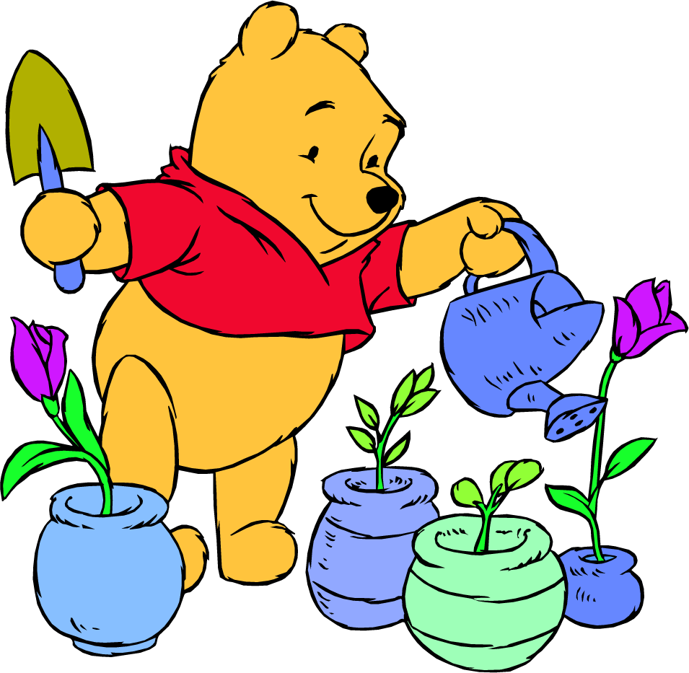Look at the picture of Winnie the Pooh, write observations about him:
   1. Write 2 quantitative observations:
   2. Write 2 qualitative observations:
   3. Write an inference:
6. Practice with Variables: Fill in the 2 variable wheels below with at least 6 variables.



Hermit Crab Growth

Amount of Snow Fall

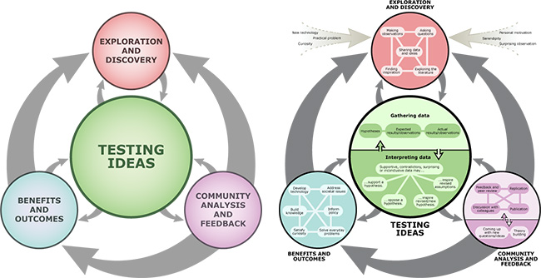

1. Study the Science Flowchart.
   1. Explain how it is different from the standard scientific method.
   2. Does every investigation go through the same steps? Why?

**PART 2:**



**Writing Prediction and Hypothesis:**

1. How does the color of the word effect the memory time of a student?
   1. Prediction:
   2. Hypothesis:
2. Does the amount of fertilizer effect how many flowers will bloom?
   1. Prediction:
   2. Hypothesis:
3. Does the position of the moon effect the height of the tides?
   1. Prediction:
   2. Hypothesis: