Greenhouse Gas Lab
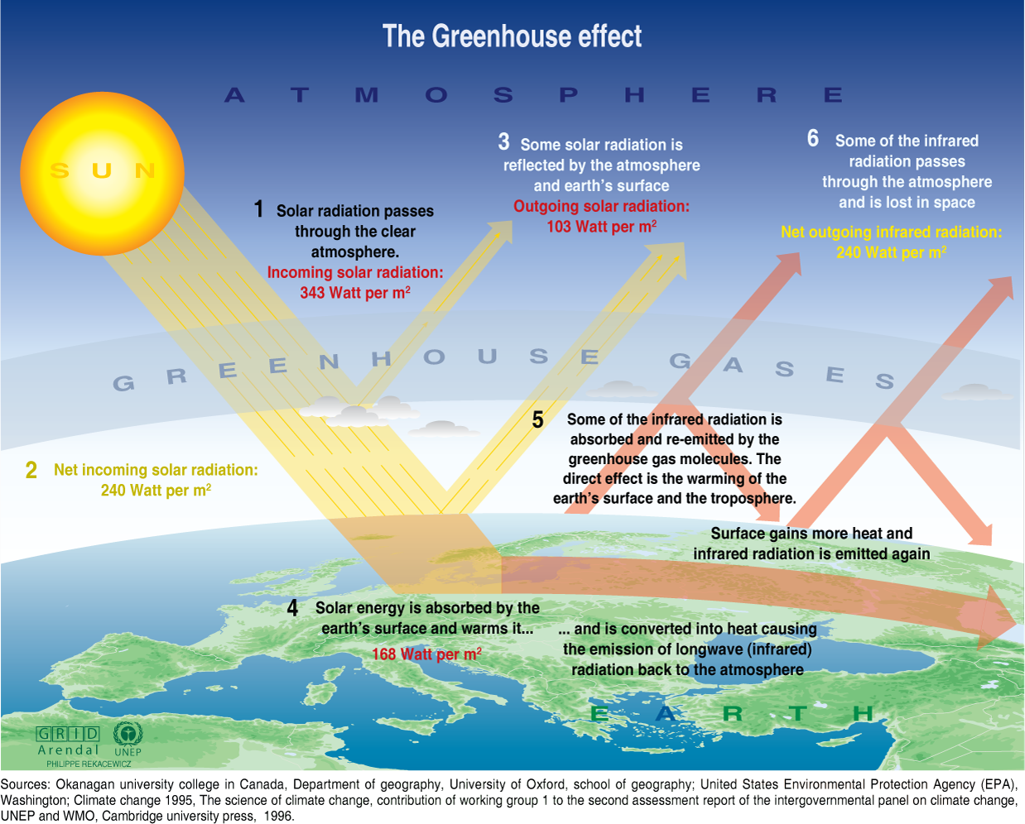
If it were not for greenhouse gases trapping heat in the atmosphere, the Earth would be a very cold place. Greenhouse gases keep the Earth warm through a process called the greenhouse effect. The Earth gets energy from the sun in the form of sunlight. The Earth's surface absorbs some of this energy and heats up. That's why the surface of a road can feel hot even after the sun has gone down—because it has absorbed a lot of energy from the sun. The Earth cools down by giving off a different form of energy, called infrared radiation. But before all this radiation can escape to outer space, greenhouse gases in the atmosphere absorb some of it, which makes the atmosphere warmer. As the atmosphere gets warmer, it makes the Earth's surface warmer, too.

Purpose:
In this lab, you will observe and measure the effect of different environmental conditions on the greenhouse effect.

Variables:
Independent Variable (IV): The variable you manipulated or changed (diet)
Dependent Variable (DV): The variable that will respond to the independent variable (what you measure).
DV units (time in sec, weight in grams, etc)
Control Test: What the IV will be compared to in order to know the change was due to your test, and not some random variable.
Constant Variables: What will remain the same during the experiment that the variables can be compared to

Hypothesis: If Independent Variable, than expectation of Dependent Variable. Write a hypothesis that makes a prediction of which environment (uncovered, covered & dry, covered & wet) will become the most hot.

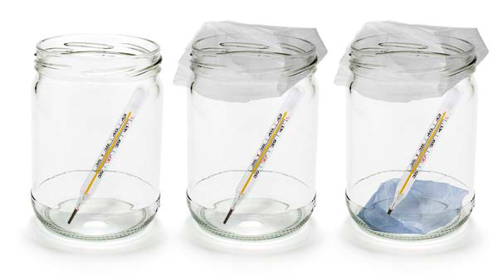
Materials:
- Multiple computers per group
- Three vernier thermometers
- Go Links (may not be necessary)
- Three equal sizes containers
- Paper towels
- Heat lamp
- Water
- Plastic Wrap or plastic bag
- Rubber band

Thermometer Procedure:
- Gather materials
- Label three containers as the following: Uncovered, Covered Dry, Covered Damp.
- Place lamp so that it is exactly above the containers.
- Place a thermometer in each beaker. Cover the “Covered Dry” beaker with plastic wrap on the top.
- In the “Covered Wet” beaker, place a damp paper towel that has been held under warm water in the beaker and cover the top of the container with plastic wrap.
- Ensure all three beakers are equal distance from the light source; place them as close as possible under the light.
- Turn on the light source and start a countdown timer for 15 minutes. Record temperature data for each environmental condition in Data Table 1 below every minute for 15 minutes.
- After 10 minutes, turn off the lamp but continue to collect temperature data.
- Collect data for 15 minutes total, record the temperature for each beaker in Data Table 1 below.
- Return supplies and clean up your lab station.

Vernier Prob Procedure:
- Gather materials
- Label three containers as the following: Uncovered, Covered Dry, Covered Damp.
- Place lamp so that it is exactly above the containers.
- Find and open the program Logger Pro on the computer.
- Place a Vernier thermometer in each beaker. Connect each thermometer to a different computer (if the thermometer is not a usb probe, it will need to be connected to a Go-Link connector and then connected to the usb port on the computer).
- Click the Data Collection Icon in Logger Pro for each computer.
- Change the settings to be as seen in the following image for each computer; the image says 20 minutes but should be 15 minutes.
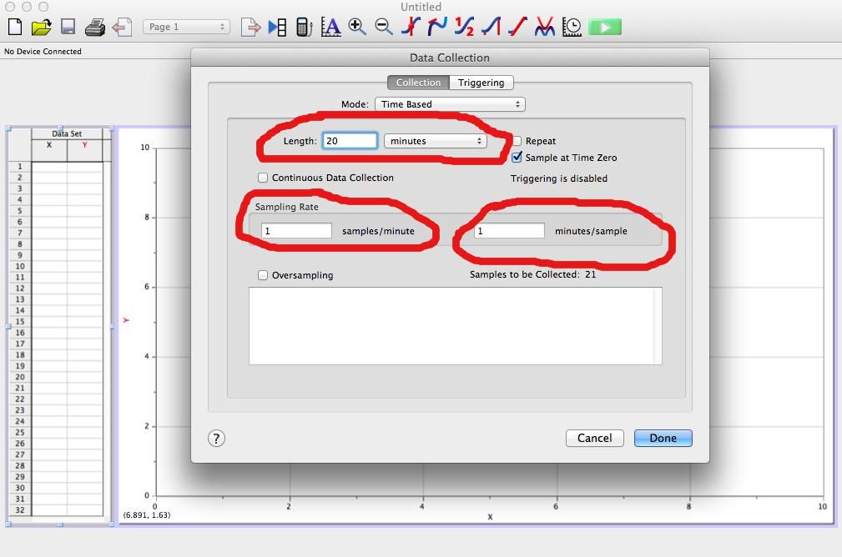
- Cover the “Covered Dry” beaker with plastic wrap on the top.
- In the “Covered Wet” beaker, place a damp paper towel that has been held under warm water in the beaker and cover the top of the container with plastic wrap.
- Ensure all three beakers are equal distance from the light source; place them as close as possible under the light.
- Click the Green Play Button on Logger Pro to begin collecting data. As data is collected it will be recorded in the program’s data table on the left hand side. Record the temperature of all three thermometers every minute for 15 minutes in Data Table 1 below.
- After 10 minutes, turn off the lamp but continue to collect temperature data.
- Collect data for 15 minutes total, record the temperature for each beaker in Data Table 1 below.
- Return supplies and clean up your lab station.

Data Table 1. Temperature (ºCelsius) in Uncovered, Covered/Dry, & Covered/Damp Environments
 |  | Temperature (ºCelsius)
Time (minutes) | Uncovered | Covered/Dry | Covered/Damp
0
1
2
3
4
5
6
7
8
9
10
 |  | Turn off Light
11
12
13
14
15

Analyzing and Interpreting Results
- Results: Make a graph with your data (y axis = dependant variable) (x axis = independent variable). Upload your graph(s) below.

- Describe results using what is observed on the graph and specific data/numbers in your answer.

- Explain Results: The above results happened because:

Conclusion Questions:
- Which environment warmed the most?

- After you turned off the heat source, which container retained the most heat?

- If the thermometers in the covered glass containers did NOT indicate higher temperatures than the uncovered thermometer, what factors could have produced your results? Explain any possible sources of error or things you would do differently if you tried the experiment again.

- Gases in Earth’s atmosphere, such as carbon dioxide, act much like the glass did in this experiment. Why did temperatures increase in the covered/dry container more than in the uncovered container? How do you think increasing amounts of carbon dioxide will affect temperatures on Earth?

- Many greenhouse gases, including some that occur naturally, are produced as a result of human activities. Predict what will happen to temperatures on Earth if we continue to add more greenhouse gases to Earth’s atmosphere.

- How can you lessen your impact on the earth?

Turn In
- Rename your personal assignment in the following way: Class_Last Name_First Name_Assignment Name
- Example: Bieber_Justin_Assignment Name
- Submit your assignment to Mr. D by using the submit assignment link on the webpage

Assessment:
 | Exceeds (4) | Meets (3) | Nearly Meets (2) | Beginning(1)
Science Standard 1: Planning & Evaluation | Hypothesis & Variables:  ❑ Hypothesis clearly articulates the expectations of the experiment and question  ❑ Several appropriate constants listed.  Evaluation:  ❑ Explains limitations, errors, or weaknesses of experiment and suggests improvement  ❑ Applies related concepts to topics in the news, scientific community, or your life.  ❑ At least one credible, external citation used (MLA format) to cite specific examples topic relates to. | Hypothesis & Variables:  ❑ States testable hypothesis  ❑ Lists IV, DV & Control  ❑ States at least two appropriate constant  Evaluation:  ❑ States an explanation, with justification, based on analysis of the data  ❑ Links findings to original question or hypothesis  ❑ States appropriate data to support the explanation, | Hypothesis & Variables:  ⠂Incorrectly identifies IV, DV and or Control  ⠂ States less than two appropriate constant  Procedure & Background:  ⠂Procedure that is not repeatable and/or clear  Evaluation:  ⠂States an explanation that does not include justification using data  ⠂Limited connection of findings to original question or hypothesis | Hypothesis & Variables:  ⠂ Does not state a testable question and/or hypothesis  ⠂Incorrectly identifies or does not include an IV, DV and or Control states less than 2 appropriate constant  Procedure & Background:  ⠂Procedure that is not repeatable and/or clear  ⠂Procedure does not have numbered steps  ⠂No background or has no connection to lab  Evaluation:  ⠂States no explanation or justification  ⠂No connection of findings to original question
Science Standard 2: Data Analysis & Technology | Data Analysis:  ❑ Calculations are used when appropriate (mode, average, error or uncertainties)  ❑ Raw data table includes title, units and calculations  ❑ Type of graph clearly illustrates data trends for analyzed data and includes units | Data Analysis:  ❑ Type of graph is appropriate for analyzed data  ❑ Labeling of graph is correct (axis, units, and title)  Technology:  ❑ Process data and report results using technology (Google Docs, Excel, and web application)  ❑ Apply a variety of digital tools to gather and evaluate information. | Data Analysis:  ⠂Raw data table does not include title, units or raw data  ⠂Type of graph is not appropriate for analyzed data  ⠂Labeling of graph is not correct (axis, units, and title)  Technology:  ⠂Uses tools for data processing or research evaluation inaccurately or inappropriately.  ⠂Use of technological resources requires significant assistance. | Data Analysis:  ⠂Raw data table is illegible or not present  ⠂Type of graph is not appropriate for analyzed data or not present  ⠂Labeling of graph is not correct (axis, units, and title)  Technology:  ⠂Does not use tools for data or research inaccurately or inappropriately.

"The Greenhouse Effect." EPA. Environmental Protection Agency, n.d. Web. 12 Mar. 2014.

