Imagine that each of the two images below show a single galaxy of billions of stars.

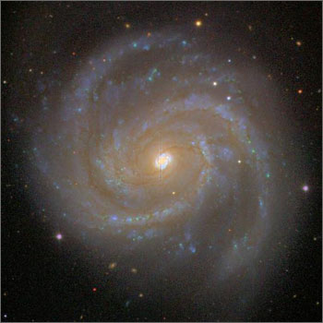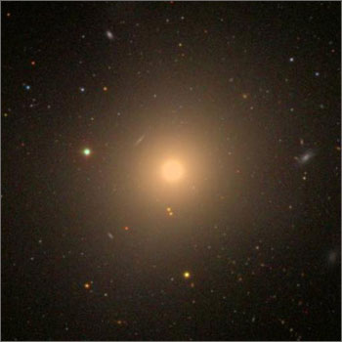
Spiral Galaxy Elliptical Galaxy

In the space below, write a detailed description of the characteristics of each that allow you to distinguish one galaxy from the other.

Observable Characteristics of a Spiral Galaxy | Observable Characteristics of an Elliptical Galaxy

