1.1 Developing Proficient/Proficient/Highly Proficient
(Remember you will be supplying this information on the test!)
Set Up: With partners sitting side by side—complete the worksheet, match find the correct definition, diagram and example for each term.

For each of the following terms, determine the matching definition, diagram and example.

Color the definition, diagram of and example(s) of atom: RED
Color the definition, diagram of and example(s) of element: BLUE
Color the definition, diagram of and example(s) of molecule: YELLOW
Color the definition, diagram of and example(s) of compounds: GREEN
Some definitions, diagrams and examples will be left UNCOLORED!
Oxygen Gas

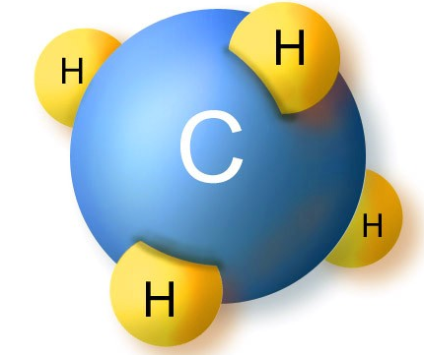
Two or more similar atoms bonded together.
Three or more similar atoms bonded together.

Chemically unique measurement of matter.

Hydrogen Gas
Carbon Dioxide Gas
Nitrate

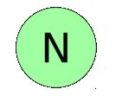
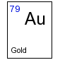
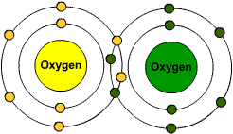
Sodium
Sodium Chloride
Magnesium
Water
Two or more different atoms bonded together.
Simplest measurement of matter.
Two or more identical atoms bonded together.

1.2 Developing Proficient (No cards needed)
Set Up: With partners sitting side by side fill in the symbol for the element, molecule and compound.
Element, Molecule, Compound | Name | Symbol
 |  | H
 | Ammonium
 |  | Zn
 | Calcium
 |  | K
 | Carbon, Hydrogen, Oxygen, Nitrogen | C,H,O,N
 | Oxygen
 |  | Na
 |  | Mg
 | Phosphorus
 | Sulfur
 |  | NO₃
 |  | NaCl
 |  | C₁₀H₂₀O₃
 | Sugar
 | Nitrogen Gas
 | Oxygen Gas
 |  | Cl
 |  | H₂O
 | Nitrogen
 | Iodine
 | Iron
 | Carbon Dioxide Gas

1.2 Proficient
Set up: With partners sitting across from each other

Part A: Stack all cards so the symbols are facing the same direction. Sort the large stack into two groups: Abiotic and Biotic.

Part B: So that your partner can see the answer—point to the card you’ll be guessing—say the name and spell it out loud—if your partner nods that the answers is correct—stack the card to show you are done. When the last card is stacked—change roles.

1.2 Highly Proficient
Set up: With partners sitting side by side.
Stack all cards so that the symbols are facing the same direction. Choose whether you would like the cards to face the symbol or the name. Place them accordingly. Then using the practice sheet—answer the ten questions on the biological functions of the elements, molecules or compounds. (Lift up cards to check answer).

1.3 Developing Proficient/Proficient
Set up: With partners sitting side by side—using one set of cards.
Part A: Stack all cards so that the symbols are facing the same direction. Sort the large stack into two groups: Organic and Inorganic.
Part B: Do the same as part A, but sort using the names of the element, molecule or compound only.

(Partners will check each other’s work for accuracy)

1.3 Highly Proficient
Set up: Given the list of organic molecules and examples—organize them into the four macromolecule categories—Nucleic Acids, Protein, Lipids and Carbohydrates.

Color Code or Number
_____Nucleic Acids _____Proteins ____Lipids _____Carbohydrates
Lipids
Nucleic Acids
RNA
DNA
Egg Yolk
Egg White
Steak
Protein
Oil
Fat
Carbohydrate
Sugar
Has C, H, O in a 1:2:1 ratio.
Has C, H, O, N
Has C, H, O—light on the oxygen
Has C, H, O, N, P (S)

