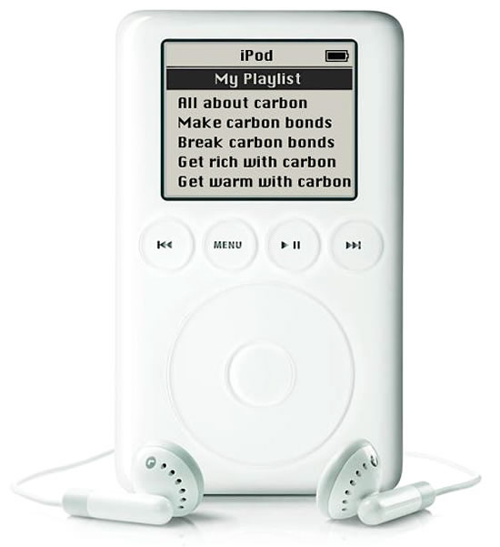

Carbon Connections by National Public Radio
http://www.npr.org/news/specials/climate/video/
- Where is carbon found?

- Why is carbon called the “duct-tape” of life? Draw a picture.
- How do fossil fuels form?
- Explain what happens when paper is burned in the fire (what are the products of combustion)?
- List four human activities that produce carbon dioxide gas.

- Draw a molecule of carbon dioxide:

- Summarize the greenhouse effect.

- Solutions: What can we do about the high levels of carbon dioxide in our atmosphere?

