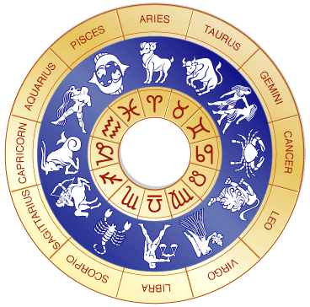
Astrology Investigation

The Question: are the Sun-Sign traits accurately associated with their respective birth-dates?
The Hypothesis: The traits associated with each sign correspond to the traits of those born under that sign
The Prediction: If this is true, then a significant proportion of us (greater than that due to chance) should find that our personality traits and interests do indeed match those described for our birth sign.
Test Procedure:
Take out a sheet of paper. DO NOT PUT YOUR NAME ON IT. Write
  - your birthday
  - the code number for the combination of traits with which they identify most closely.
  - (YES) or (NO), astrology can give accurate information

4. Students fold their sheets in half, hiding their information, and hand them in when called for.
5. Teacher re-distributes the sheets so students do not get their own sheets.
6. Students indicate HIT or MISS on the sheet, based on the key.
7. Teacher takes show of hands tally of HITs and MISSes, and records.
8. Teacher also counts numbers of YESs and Nos (show of hands), and records.

Analyze results by applying mathematical laws of probability to determine whether the results are due to chance alone or not.

Name______________________________________ Per.___ Date________

RESULTS: Bellief in astrology: There were ______ YESs, and ______ Nos in this class of

RESULTS: There were ______ HITs, and ______ MISSes
RESULTS in other classes data from teacher: ____ HITs, and _____ MISSes ... for total of _____ students
PROBABILITY RESULTS DUE TO RANDOM CHANCE:
1. What is the probability that one individual would select the “right” number, just by chance? 1/____
2. What is the total of all of these individual probabilities?
(the individual probability, step 1, times the total number of students) = ________
3. So, about how many students would you expect to select the right number just by chance alone? _____

DISCUSSION QUESTIONS
4. If the class total of hits is close to chance, what does this tell us about the predictability of Sun Signs?

5. If the class total of hits is significantly higher than expected, what could have caused this? (list 2-3)
How could you critically test or control for each possibility?

6. How did this class’ results compare with the results in other classes?

7. If Sun Signs are so fundamental to horoscope interpretation, what do our collective results suggest about the predictability, validity and potential usefulness of horoscopes?

8. What problems did you find in trying to select the Sun Sign description which came closest to how you see yourself?

9. What other tests of astrology can you think of?

10. Why might a person think that his or her horoscope seems to be true?

11. Astrology is “The oldest empirical science in the world.” (Hewitt, 1997, p. 16). Astrology is based on ancient beliefs about planets and stars, employing mysterious patterns and complex calculations to reveal details of individual personalities and potentials, and provide the basis for critical decisions in one’s life. Repeated tests and challenges which could have provided support for astrology (“Fair Tests”) have consistently shown the process to be unreliably predictive or descriptive. Furthermore, no mechanism to explain the purported relationship between personalities, destinies, and heavenly bodies has ever been demonstrated; astrology allegedly continues to function due to “mysterious forces”. Explain why astrology is NOT a science, but rather a pseudoscience.

12. Do you now think that astrology can give accurate predictions (YES) or not (NO)? ________

HW: Watch James Randi and test of astrology with college students 1:34 minutes.
http://www.youtube.com/watch?v=3Dp2Zqk8vHw
In your comp book, describe the test method and materials. Describe the qualitative results. Finally interpret the results. What conclusion can be drawn? Support your claim with evidence.

James Randi and Faith Healing http://www.youtube.com/watch?v=q7BQKu0YP8Y
Reflect: Why do you think James Randi pursued exposing the faith healer as a fake, instead of ignoring him as harmless? What does this example have to do with science?

