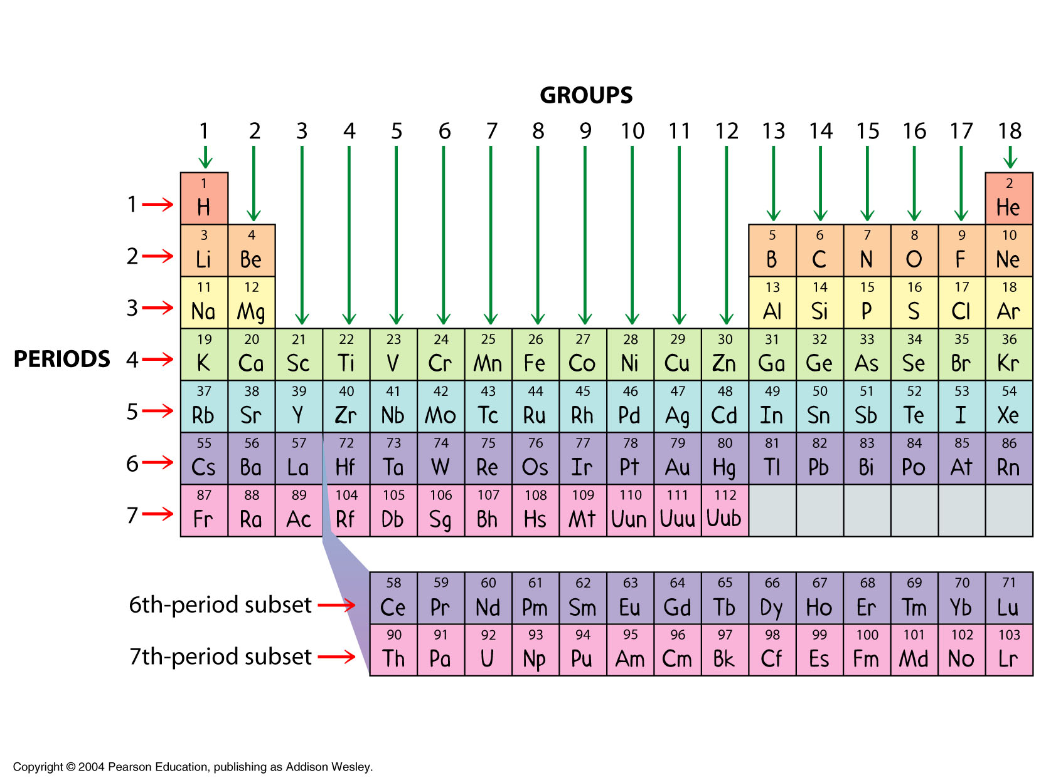

**atomic number:**________________________

_____________________________________

**atomic mass:**__________________________

_____________________________________

**valence e-:**____________________________

**6**

**7**

**isotope:**______________________________

**ion:**

cation: _____ Groups:______________________________________________________________________________

anion: Periods:______________________________________________________________________________

|  |  |
| --- | --- |
| **METALS** | **NONMETALS** |
|  |  |
|  |  |
|  |  |
|  |  |

*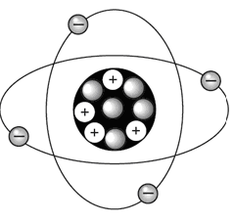Label the atom and identify the element:*

element:_____________________________ IONIC BONDS:_________________________________________________________________________

Is this an isotope or an ion?______________ Ionization:____________________________________________________________________________

**How to make IONIC BONDS**: Name:_______________________

* Bond a ___________ ion with a Date:______________Period: ___ _______________charge with a _________________ ion with a _______________charge.  
   THE PERIODIC TABLE
* Sum of oxidation #s in a neutral compound is **ALWAYS** ______!!  
   OF THE
* Any ___________ compound’s overall charge is ALWAYS ____! ____________________________
* Ionic compounds and their _________ (how many of each) are shown in a _____________ The ___________________of _______________ ex: Mg Cl ELEMENTS according to

_____________________ and

CRISS-CROSS METHOD (shortcut)

___________ _____________

Purpose: _________________

________________________