Crater of death documentary
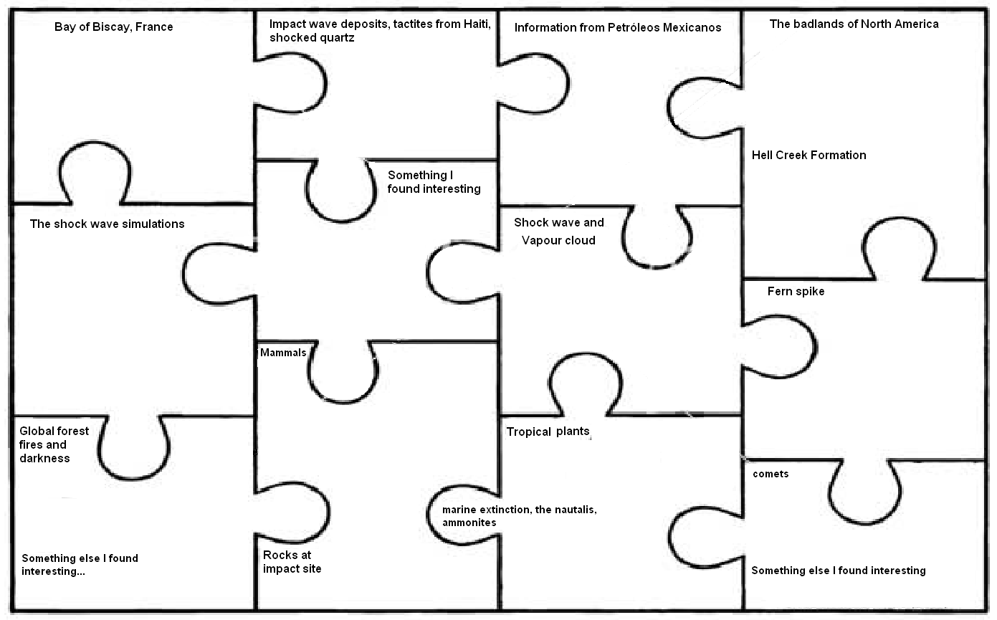The dinosaur extinction has puzzled scientists for years. Every clue that scientists have uncovered is like a piece in the puzzle. When we put these clues together we can build up a complete picture of what happened on the fateful day the asteroid struck, as well as the sequence of events that followed. As you watch the documentary, make notes under the headings. Explain how this clue contributed to our understanding of the event. (i.e. what did we learn from it? How did it enhance our knowledge of the extinction event?
Some scientists believe timing and size of impact is more consistent with a comet than an asteroid
Ammonites became extinct because of darkness. But their cousins, the nautalis which lived much deeper in the ocean survived.
Further evidence for a warm period following the impact caused by atmospheric CO2
Rocks contained high amounts of carbon and sulphur. When they vapourised it produced carbon dioxide and sulphur aerosols .
Mammals that fed on dead plant material and insects were able to survive.
Geological surveys showed strange circular shape in ocean floor
Forest fires caused by the heat of rocks and ejecta re-entering the atmosphere. The world burned for days
Ferns often grow first on devastated land. So the presence of ferns suggested other plants had been wiped out
Hundreds of fossils found (e.g. ammonites) found in layers of rock. They suddenly disappear above iridium layer.
Asteroid hit at oblique angle, vapourized rocks at surface
Showed shape and size of impact crater
Abundance of fossils proved dinosaurs died out suddenly, no gradual decline
Fossils and dinosaur footprints over millions of years, suddenly disappear after iridum layer
Evidence of extreme heat and power - helped scientists find the impact crater

