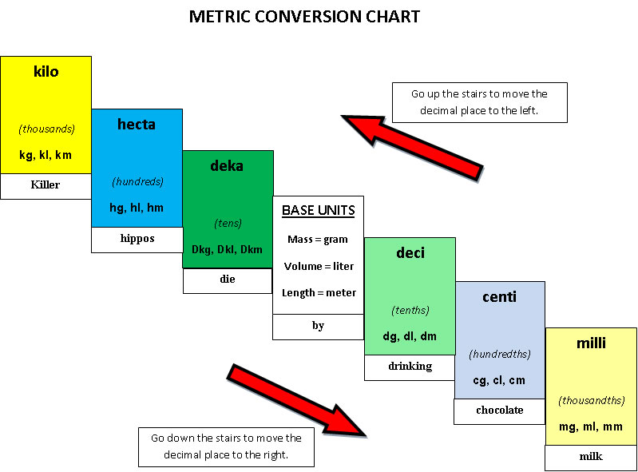

**Name:** ______________________________________ **Hour:** ______

**Name:** ______________________________________ **Hour:** ______