Your Carbon Footprint
Your carbon footprint can be measured in several ways. The simulation used in this activity measures how many tons of CO2 and other greenhouse gases you produce each year. This model uses averages based on your location, and customizes the model based on your responses to several questions.

Procedure:
- Visit Nature’s Carbon Calculator
- Chose to complete the model for you only
- For each of the tabs pictured below, answer all of the questions asked to the best of your knowledge.

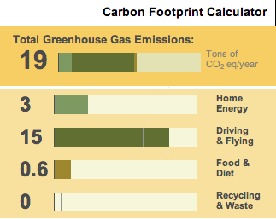

- As you complete the questions notice how the Total Greenhouse Gases chart to the right changes.

- Complete the following questions when done:
  - How many total tons of CO2/ year do you produce:

  - How does the global average compare to your average?

  - Which activity contributes most to your carbon footprint?
  - Describe why the global average is so low compared to your average.

  - Predict how you think your footprint changes as you get older.

  - What assumptions do you think the model is making about you or other americans?

